Software Requirements

* Requirement collections and Analysis
* Software Configuration:

This Software package is developed using flutter framework which supported by IOS and Android Operating system. Firebase use for database.

* Hardware Configuration:

API: 15

Android version: 7.8

IOS version: 11

Ram: 2 GB

ROM: 16GB

* Analysis
* Purpose

one that refers to the use of e-commerce as a marketing medium; retail and wholesale; auctioning; e-banking; booking, and so on.**E-commerce applications** is a slightly confusing phrase since it leads to two different perceptions: one where it refers to the use of e-commerce as a medium of marketing; retail and wholesale; auctioning; e-banking; booking, and so on.The second concept that comes to mind is a software program like Amazon, eBay, Groupon, etc. It might be a web application or [**applications of e-commerce**](https://lilacinfotech.com/what-we-do/retail-e-commerce-app-development) (now popularly known as m-commerce applications). **Mobile e-commerce applications** are just an extension of e-commerce. Mobile app concepts are the driving force behind any successful business app, whether a [**cab booking app**](https://lilacinfotech.com/what-we-do/taxi-booking-app-development-india) or a [**food delivery app**](https://lilacinfotech.com/what-we-do/food-delivery-on-demand-app-development-india).

First Screen:



Home Screen:

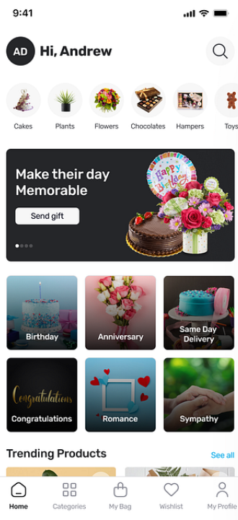

Categories Screen:

